Paula Lantsberger, MD, MPH, FACOEM
Patient Pain Drawing

Name _____________________________________________ Date________________

Where is your pain now?

• Mark the areas on your body where you feel the sensations described below, using the appropriate symbol.
• Mark the areas of radiation.
• Include all affected areas.
• To complete the picture, please draw in your face.

Aching Numbness Pins and needles Burning Stabbing
N N N = = = O O O x x x / / /
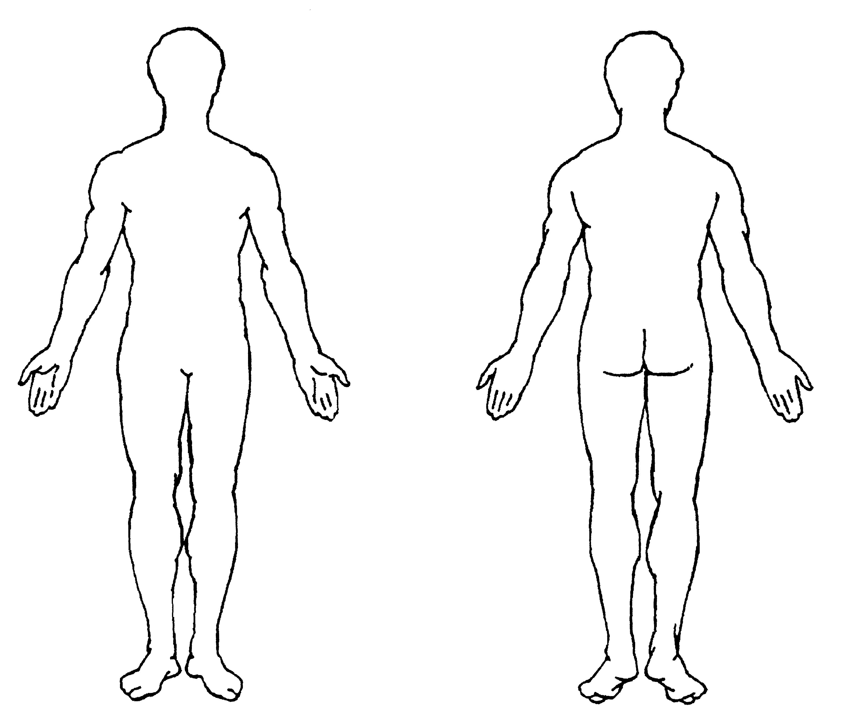
Back
Front

Left ht
Right
Left ht
Left
Left
Right
How bad is your pain now?
• Please mark with an X on the body form where the pain is worst now.
• Please mark on the line how bad your pain is now:

No pain ______________________________________________Worst possible pain

THE JOURNAL OF MUSCULOSKETAL MEDICINE
Volume 6, Number 9 – September 1989

